1. pid → first_name, last_name, address, phone_number, date_of_birth, years_coached

tid → team_name, hcid, agid

agid → description, minimum_age, maximum_age

hcid → pid, tid



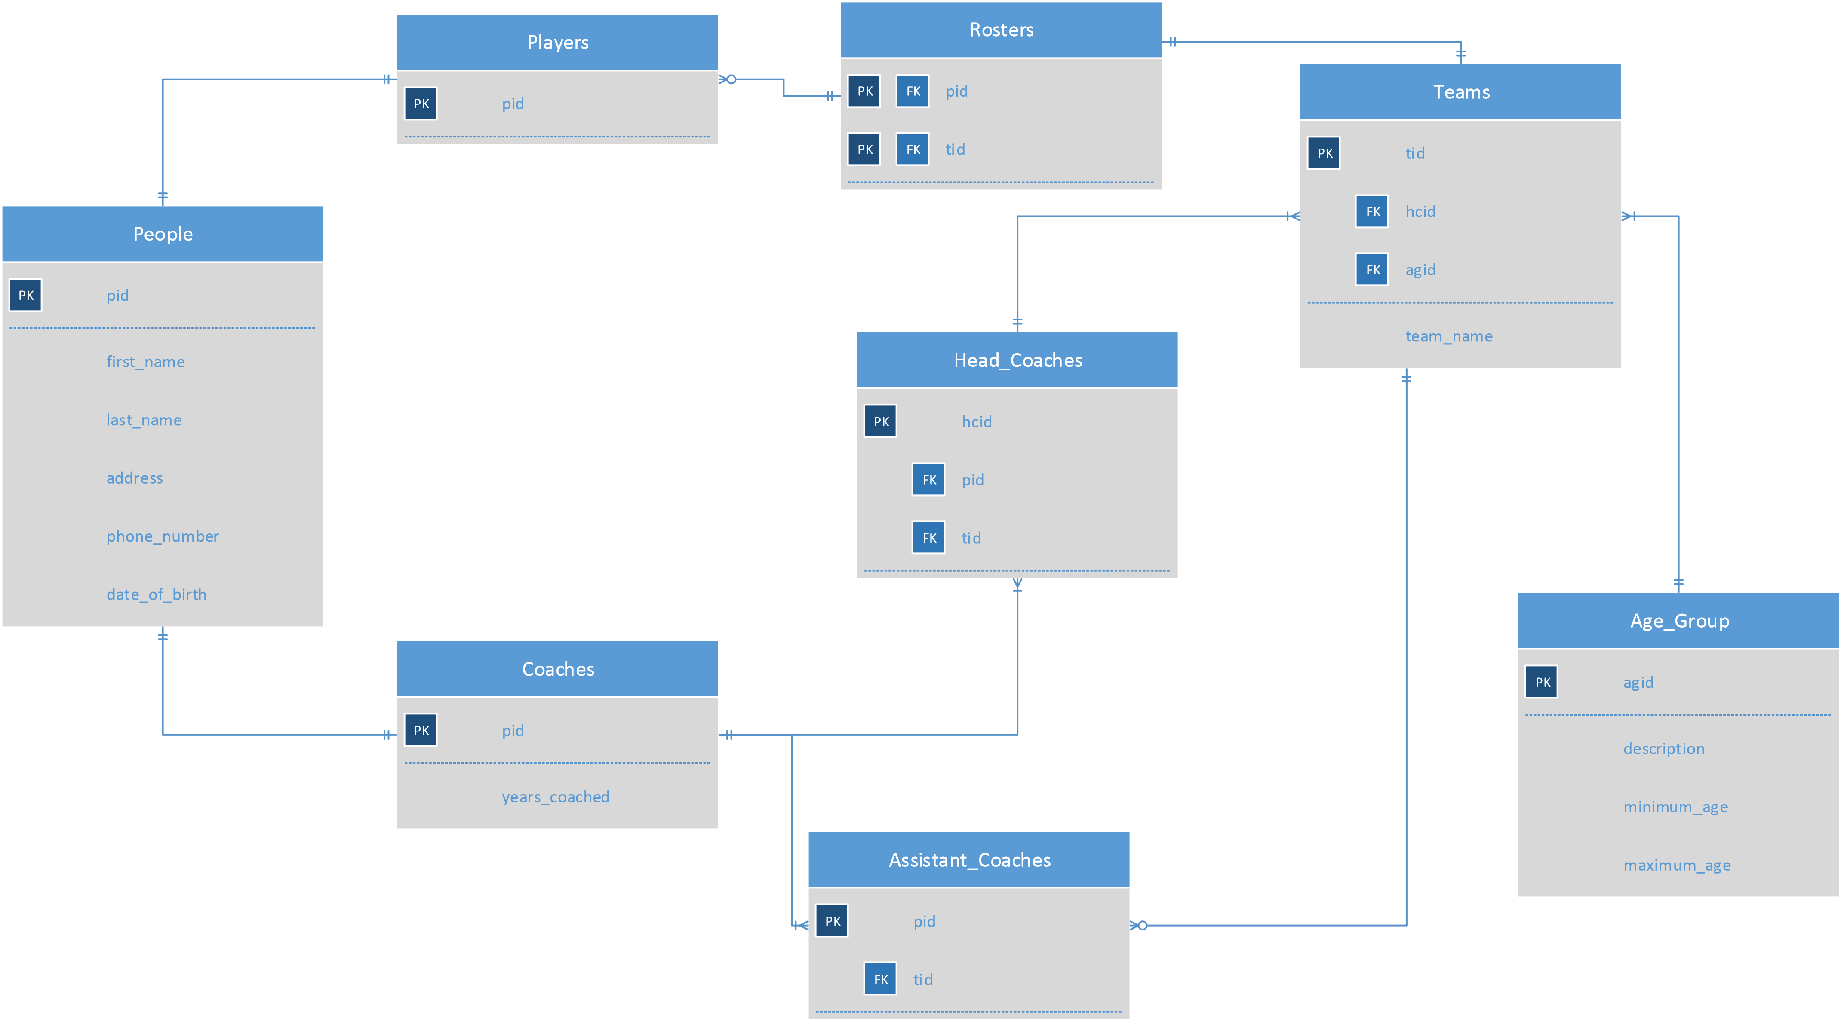

1. All of the non-key attributes of any tree can be found using the primary key of the table, deleting chances of update anomalies meaning that the tables rely on nothing but the key.
2. create view farm_league as

select t.team_name, t.tid

from teams t

where t.agid = 2